RIPHAH INTERNATIONAL UNIVERSITY, ISLAMABAD


Assignment 2
Bachelors of Computer science – 7th semester
Subject: Parallel and Distributed Computing

Submitted to: Ma’am Hajra Murtaza
Submitted by: Munaza Malik
Sap Id: 44956
Date: 12th October, 2025

Task:
We need to implement a function that calculates the sum of elements of a 10000 array of integers serially i.e. with one thread and then with multiple threads. Note the execution times for each version and calculate the speed up with the multithreaded parallelized version. Give speed up with 4, 5 and 10 threads.
Note: We will have to initialize the array with random numbers - This will be the considered the non-parallelizable code. The sum calculation will be broken into smaller tasks assigned to each thread.
Code:
Part 1: Serial Version
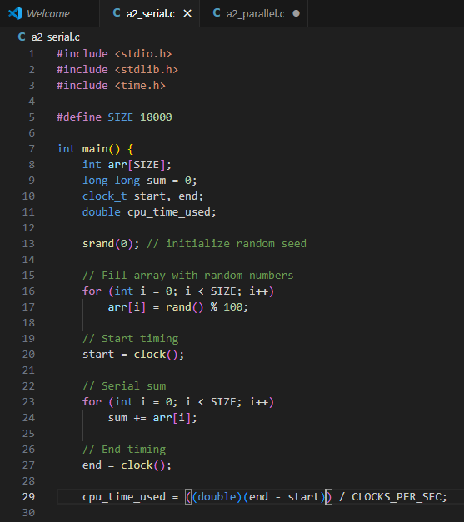
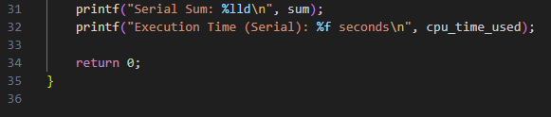
Part 2: Parallel Version (Multithreading using pthreads)
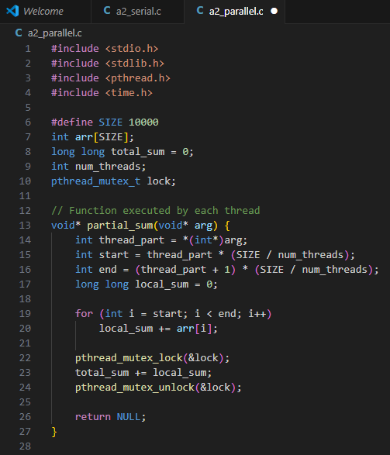
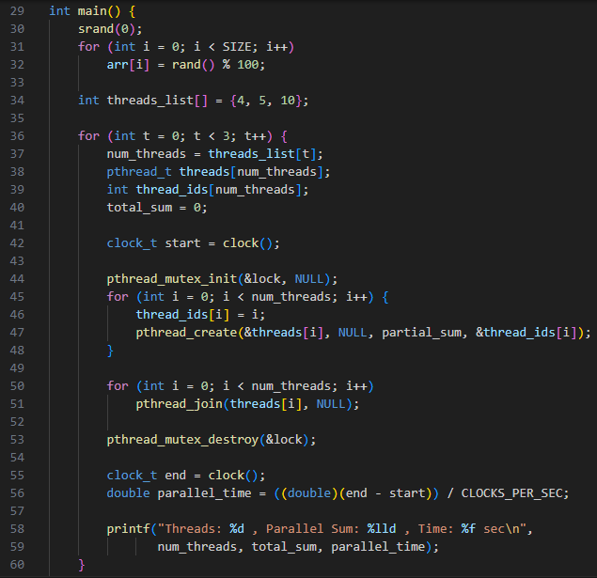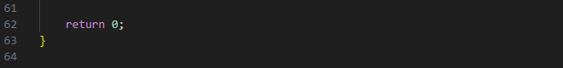

Output:
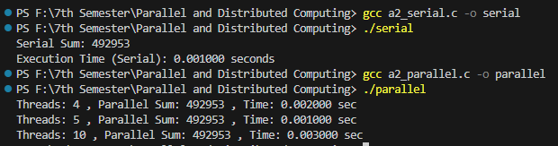
Speedup:
Serial Time = 0.001000 seconds
Parallel Time:
Threads | Parallel Time | Speed Up = 0.001000 / Parallel Time
4 | 0.002000 seconds | 0.5
5 | 0.001000 seconds | 1
10 | 0.003000 seconds | 0.3333

Parallel version is slower. For small arrays, multithreading doesn’t give speed-up — it actually slows down due to overhead. The serial program was faster than the multithreaded one. This happened because creating and managing threads takes extra time when the array is small.
If we use a larger array, the multithreaded version will start to work faster and give better results.
The parallel version became slower because the computer spent more time managing threads than actually doing the sum.
The serial version finished faster because it didn’t waste time starting or coordinating multiple threads.

